#### KOCITY5 ENTERPRISE SALES REPORT: A COMPREHENSIVE REPORT BY AKOR DENNIS ENECHE

**INTRODUCTION:**

In today’s business environment, we all can attest to the fact that data driven decision-making is imperative for the success of any company. Kocity5 enterprise, a leasing company in Europe, recognizes the importance of making strategic business decision with data to improve its profit and fain more market shares. As a new data analyst at Kocity5 enterprise, I have been tasked with analyzing the company’s sales data over the years and build an interactive dashboard with Microsoft Excel to help make informed decisions.

**PROBLEM STATEMENT:**

The goal of the goal the company is to optimize its sales strategies and improve overall profitability. Apparently, kocity5 enterprise management lacks clear understanding of factors that are most influential in driving sales performances. To be more specific, there is a need to identify factors such as seasonal trends, demographic contributions and overall product performances. With this analysis, strategic decision making will easier and potentially leading to growth and sales.

**PROJECT QUESTIONS:**

This project focusses on answering key business questions that important for understanding kocity5 enterprise performance. The project questions are as follows:

Which quarter has the highest profit?

Our top three selling products?

How is profit performing over the years?

Which quarter has the highest profit?

Profit by age group?

Profit by gender and others

**AIM:**

By addressing these questions, I seek to provide actionable recommendations to the management which will help make informed decision and foster proper planning for the next business year.

**ABOUT THE DATASET:**

The data was originally sourced from Kaggle. But for the project’s sake, we are assuming its kcoty5’s company data gotten from our database. The dataset constituted 10 columns respectively, comprising of different columns such as date, gender, company’s products, cost etc. There were lots of missing columns and judging by the project questions we will have to create new columns.

**DATA PREPARARTION:**

In order to achieve the set goals, I will need to cleaned, standardized and well-structured data that is ready for analysis. This will involve importing the dataset, cleaning it, creating new columns for years, age group, month, quarter, profit and revenue

1. Upload/ preview of the dataset in excel workbook.

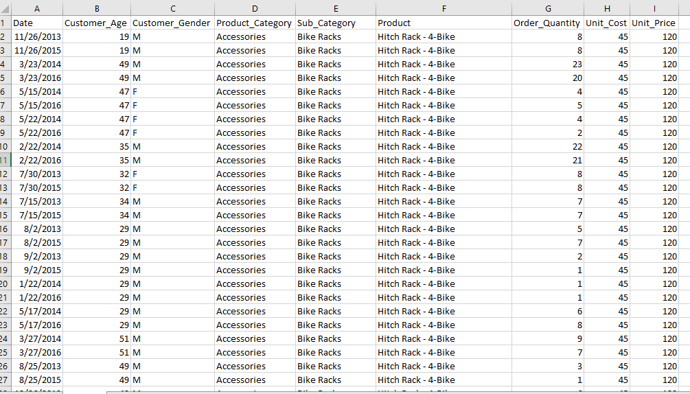

1. Checking for duplicates values

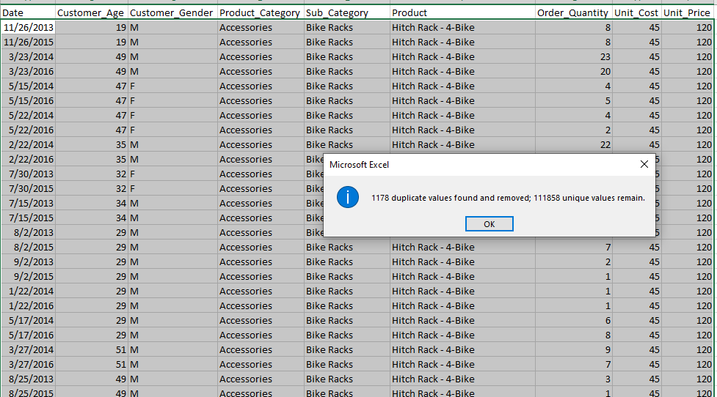

There was about 1178 duplicate values removed

1. **Data structuring.**

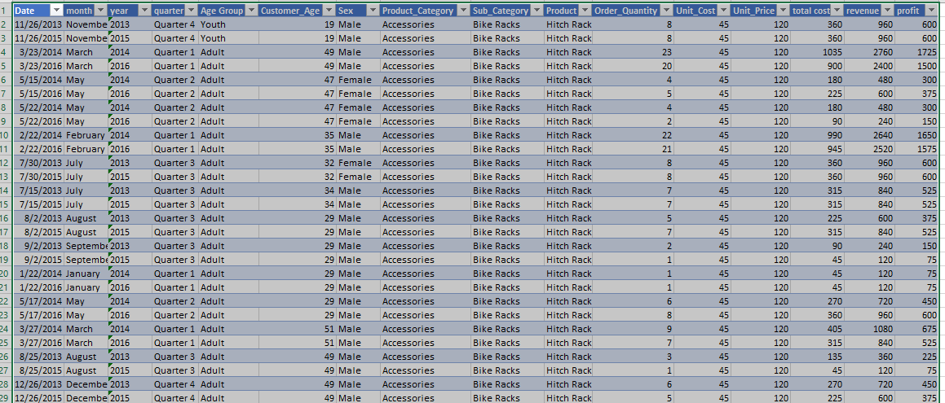

I structured the data for easy cleaning using CTRL + T, then I renamed the dataset.

1. Created new columns for years, month, age group, quarter, profit and revenue



Created years column using =text (date column,” yyyyy”)

For month = text (date column,” mmmm”)

For quarter column we used the IF function =CHOOSE(MATCH(MONTH(D2), “q1”, “q2”, “q3”, “q4”)

For age group column we also used the IF function =IF (E2<25, “Youth”, IF (E2<65, “Adult”, “Old”))

1. Remodified gender column

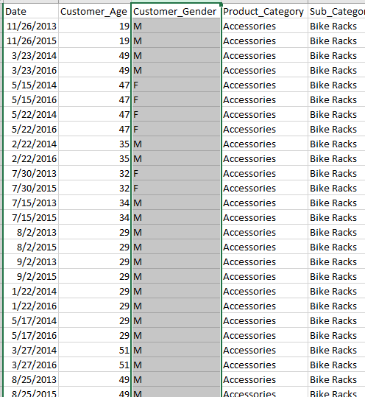

Ordinally, the gender column was characterized by M & F. I wanted it to be readable and easy to understand so I replaced them with male & female.

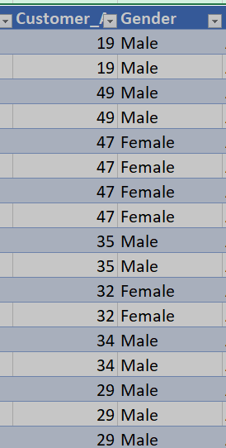

This was done using the IF function =IF (H2=”M”, “MALE”, IF (H2=” F”, “FEMALE”))

**DATA VISUALIZATION**

Data visualization plays a crucial role in understanding datasets by providing a clear picture before implementing models. Exploratory data analysis aims to delve deeper into dataset insights using pivot chart

DASHBOARD:

Created six different charts to answer the project questions and I added two slicers for deeper understanding of the data. KPS on profit, revenue and total customers.

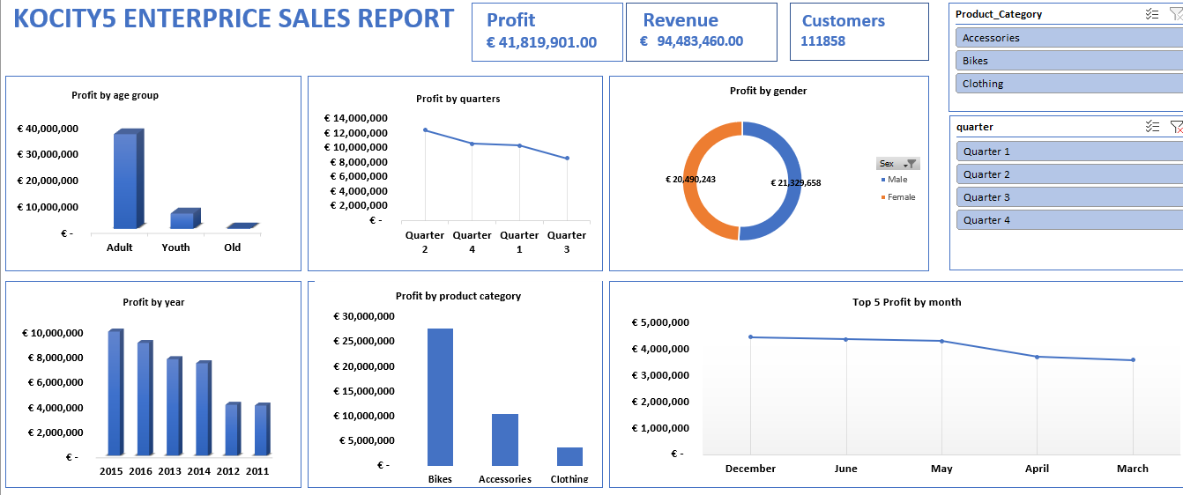

**Key Insights from Kocity5 Enterprise Sales Report**

**KPI:**

Profit: €41,819,901.00

Revenue: €94,483,460.00

Customers: 111,858

**Profit by Age:**

Profit is almost evenly split between male and female customers, indicating balanced marketing efforts and product appeal to both genders.

**Adults**: Generate the highest profit, around €36 million.

**Youth**: Moderate profit, approximately €8 million.

**Old**: Lowest profit, about €2 million.

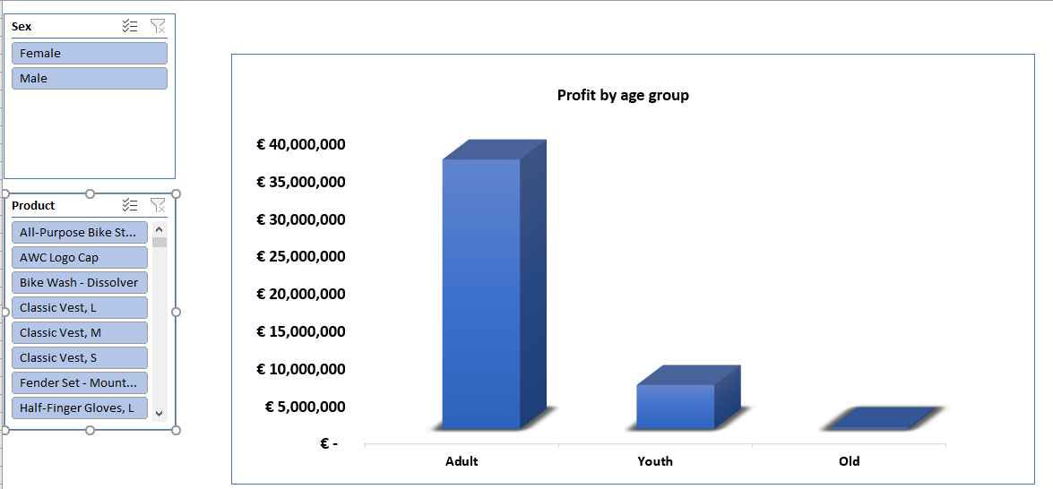

**Profit By Quarters:**

The second quarter shows the highest profits, suggesting potential seasonal trends or successful campaigns. Emphasizing strategies from Q2 in other quarters could boost overall profits.

• Quarter 2: Most profitable.

• Quarter 4: Second most profitable.

• Quarter 1: Third in profitability.

• Quarter 3: Least profitable.

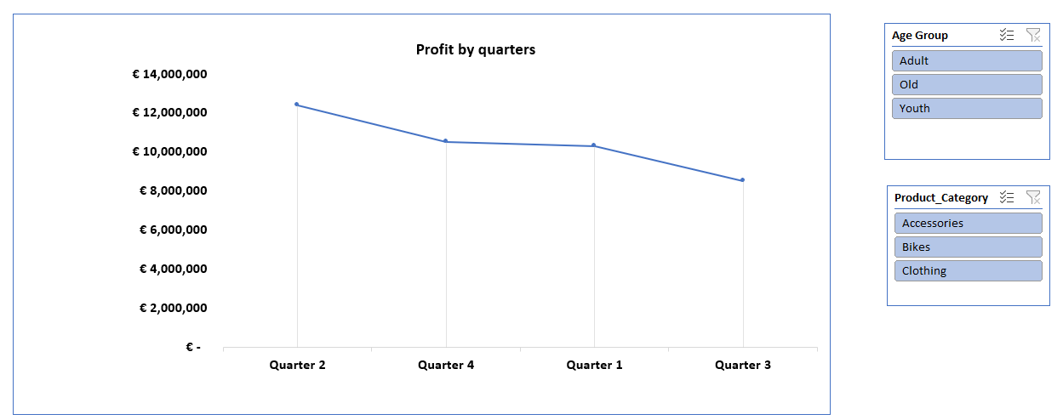

**Profit By Genders**:

Profit is almost evenly split between male and female customers, indicating balanced marketing efforts and product appeal to both genders.

• Male: €21,329,658.

• Female: €20,490,243.

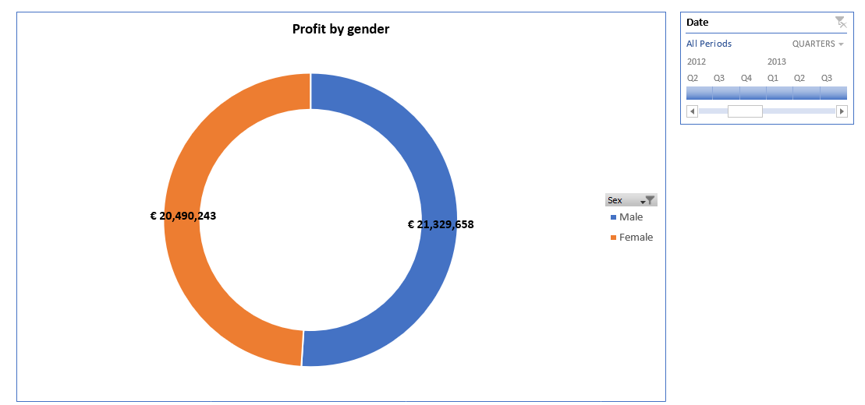

**Profit by product-category:**

Bikes generate the highest profit, indicating strong market presence and demand. Accessories perform well, while clothing lags behind. Evaluating the clothing line’s performance and potential improvements or discontinuation could be beneficial.

• Bikes: Highest profit, about €28 million.

• Accessories: Moderate profit, roughly €9 million.

• Clothing: Lowest profit, around €2 million.

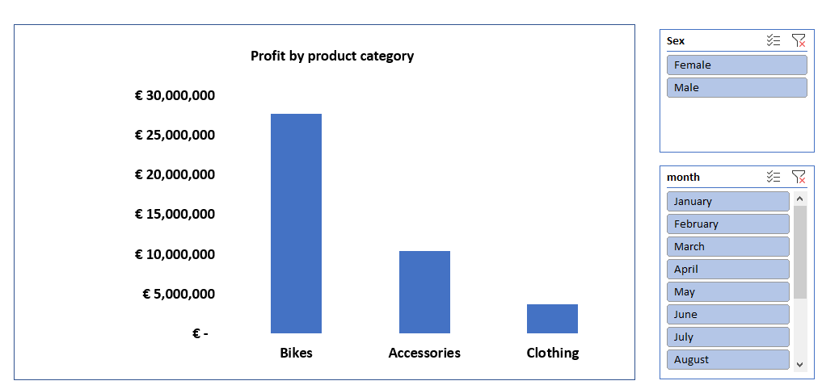

**Profit by year:**

A peak in 2015 followed by a general decline. Investigating the causes behind the peak and subsequent decline could help strategize future growth.

• 2015: Highest profit, near €10 million.

• 2016, 2013, 2014: Similar, slightly lower profits.

• 2012, 2011: Significant decline, with 2011 being the lowest

.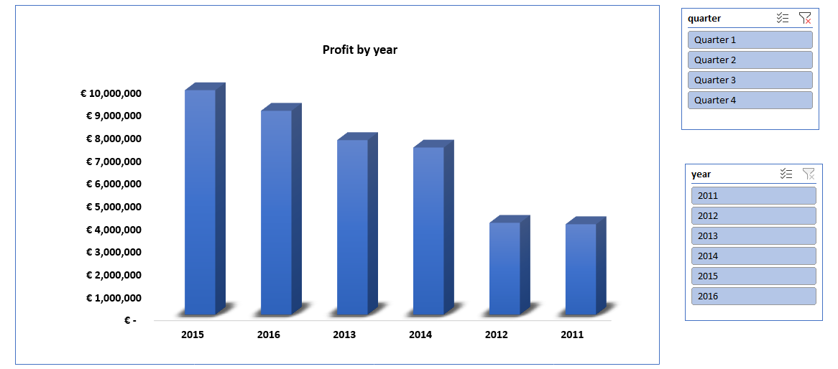

**Profit by months**:

December is the most profitable month, likely due to holiday shopping. June and May also perform well, suggesting mid-year promotions or demand. Replicating successful strategies from these months could improve performance in other months.

• December: Most profitable month.

• June and May: Consistent and high profits.

• April and March: Lower but still among the top 5.

**RECOMMENDATION**

Enhanced Focus on Adult Customers:

Develop products and marketing campaigns specifically tailored to adult preferences and needs.

Leverage Successful Quarter Strategies:

Analyze and apply the successful strategies from Q2 to other quarters to boost overall yearly profits.

Balanced Marketing for Genders:

Continue balanced marketing efforts to maintain equal appeal to both male and female customers.

Investigate Yearly Profit Declines:

Conduct a detailed analysis to understand the factors contributing to the decline post-2015 and implement corrective measures.

Boost Clothing Category:

Review the clothing product line, customer feedback, and market trends to identify areas for improvement or innovation.

Seasonal and Monthly Promotions:

Design promotional campaigns around high-performing months like December, June, and May, and experiment with similar tactics during lower-performing months.

**CHALLENGES:**

Completing the project within a limited timeframe posed challenges for thorough analysis and validation, requiring efficient project management to balance the depth of analysis with the project timeline.

**CONCLUSION:**

The analysis of Kocity5 Enterprise's sales report reveals significant insights into the company's performance across various demographics, time periods, and product categories. The findings highlight strengths such as high profitability from adult customers, strong performance in the second quarter, and a profitable bike product category. Additionally, the nearly equal profit distribution between genders indicates effective marketing strategies. However, the report also uncovers areas for improvement, such as declining profits in recent years, the underperformance of the clothing category, and fluctuations in monthly and quarterly profits.